Agency One Pagers
One pagers are sent weekly to: TN, UWJC, TSA, THAW, UWSEM, SVDP, BCAEO and SWP. I send a one pager quarterly to BCUW, the same week as our quarterly call with them. The document are stored: K:\CustOpsStrategy\Process\RevOps\Low Income\2021 Fiscal Year\Outreach\Agencies\Agency Visual Management
- Prepping the documents: I start by opening each one pager updating the date and removing the financial tables I then save it with the current date and use that as my template for the weekly one pager.
- Dashboard: The enrollment counts and financials for each agency can be found on the dashboard https://customeranalytics.ce.corp.com/ Hover over Customer Operations and the below menu will pop up. Under Revenue Operations you will see “Low Income Funding Analysis” which is the dashboard you will need to complete the one pagers.
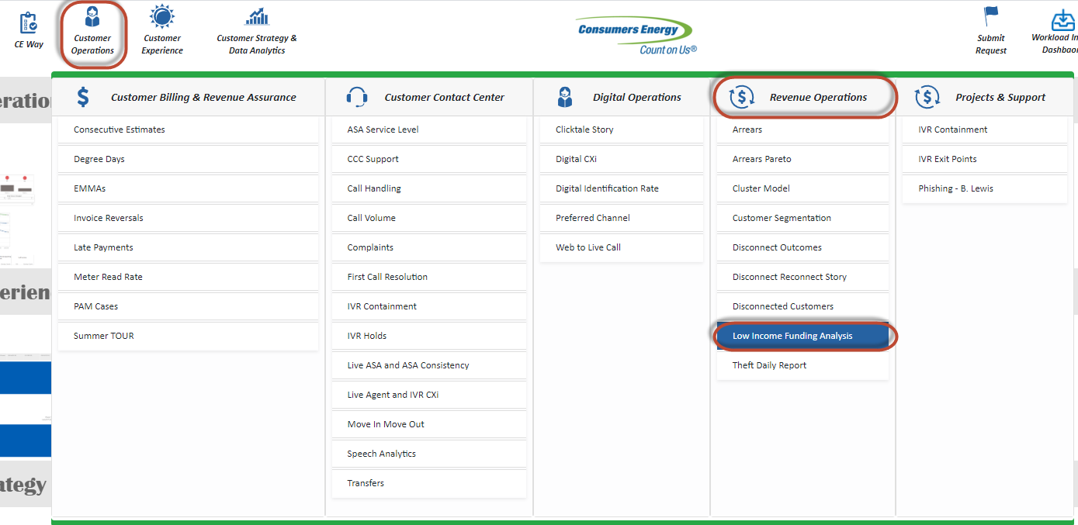
- Updating Enrollment #s: The enrollment counts for each agency can be found on the dashboard under the CARE Summary Tab. The table labeled CARE Enrollment PY 1 is used for the new enrollments. CARE column is for all agencies. The CARE D column is CARE+ enrollments for TN, UWJ and THAW. The Table labeled Current Customers is used on BCAEO’s one pager to document how many of their pilot customers are enrolled in CARE E (Civilla/Wayne Metro Pilot from FY20).
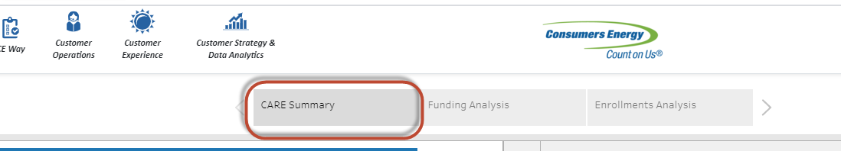
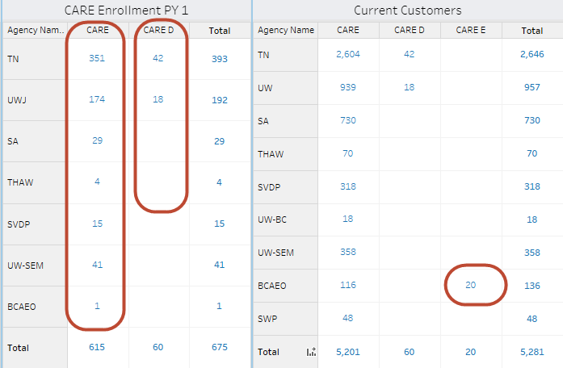

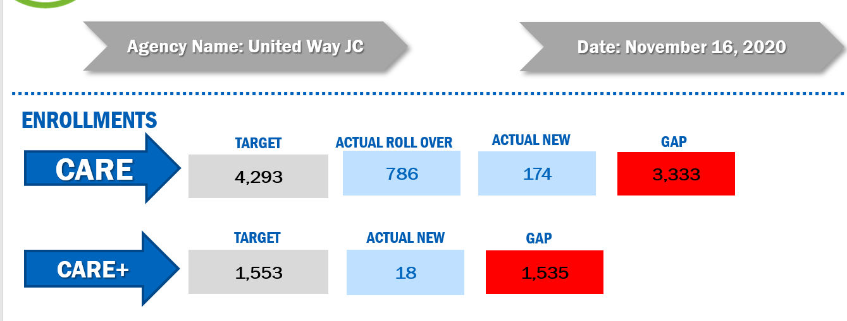
Target – Rollover – Actual New = Gap
- Updating Financials: The financial information for each agency can be found on the dashboard under the Funding Analysis Tab.
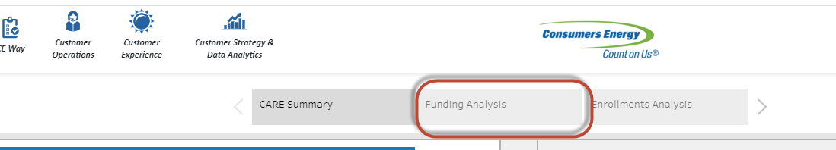
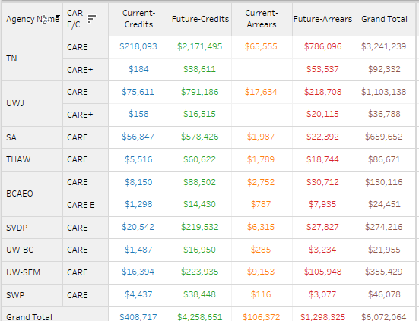
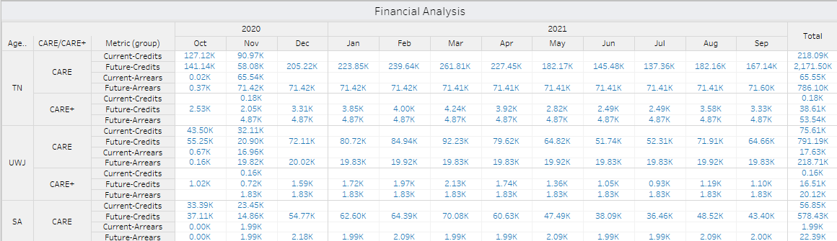

Once you add screenshots from the dashboard to the one pager you will need to update the boxes on the one pager.
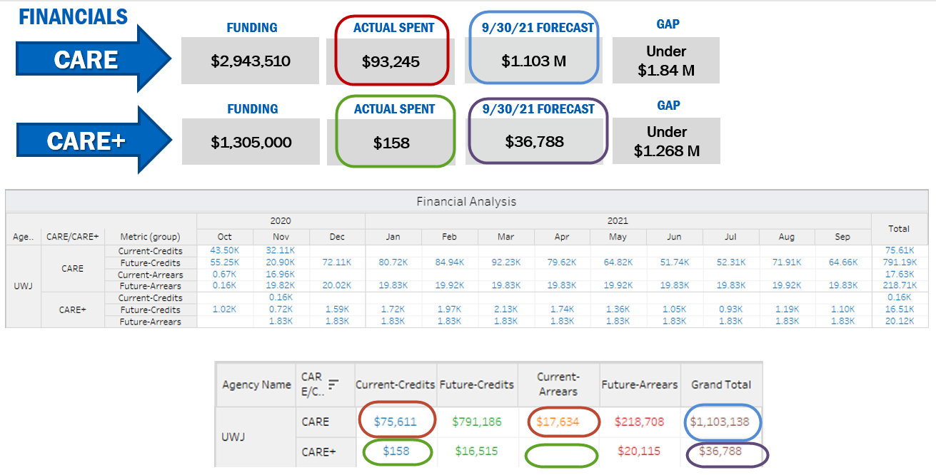
Current Credits + Current Arrears = Actual Spent
Grand Total = 9/30/21 Forecast
Funding – 9/30/21 Forecast = Gap
- Save the PowerPoint document and save as a PDF.
- Open the calendar invite for the agency call and remove PO Box: Care, yourself and Jon Clark from the message. Update the subject line to Agency/CE Weekly Update. Attach the PDF one pager for the agency to the message. Add to the body of the text whatever you’d like, I normally say “Good Morning, attached is the weekly status report” and send.
- Save all PDFs and ppt docs in the Agency Visual Management Folder-FY21-Date sent

